  - Sport NZ
  - Community Resilience Fund Phase 2 (July to Sept 2020)

  - _

  - Application Form Questions
July 2020

Content

Introduction – 3
Who can Apply – 4
Application form - 5

Introduction
Sport NZ ‘s vision is simple - to get Every Body Active in Aotearoa New Zealand.
As Aotearoa re-sets and re-builds post Covid-19, we know that many play, active recreation and sport organisations are going through a difficult time. Sport NZ has developed a Recovery Package to help support play, active recreation and sport organisations get back on their feet following the Covid-19 lockdown. The Sport NZ Community Resilience Fund Phase 2 (the Fund) forms part of this Recovery Package.

Purpose of the Sport NZ Community Resilience Fund Phase 2
The Fund aims to provide financial support to play, active recreation and sport organisations that are experiencing financial hardship in the period 1 July to 30 September 2020, as a result of Covid-19. It is to help ensure that those organisations are able to continue delivering quality physical activity experiences to get Every Body Active in Aotearoa New Zealand.
We welcome applications from organisations that have not previously received funding from Sport NZ, and those that may have received some support already through the earlier Community Resilience Fund in May/June 2020. The Fund is not intended for organisations that already receive investment directly from Sport NZ.
This Fund provides additional financial help on top of other relief such as the Government Wage Subsidy, other sources of funding, and support from national bodies.

Further information and enquiries
For questions about this fund or the eligibility and criteria to apply for this fund, please read the Community Resilience Fund Phase 2 guidelines, or consult the FAQ document. This will be updated for new questions that arise during the application period.
Queries not addressed in these documents may be emailed to your relevant Regional Sports Trust.

Who can apply
The Fund is open to a wide range of organisations. Please use the diagram below to test your eligibility.
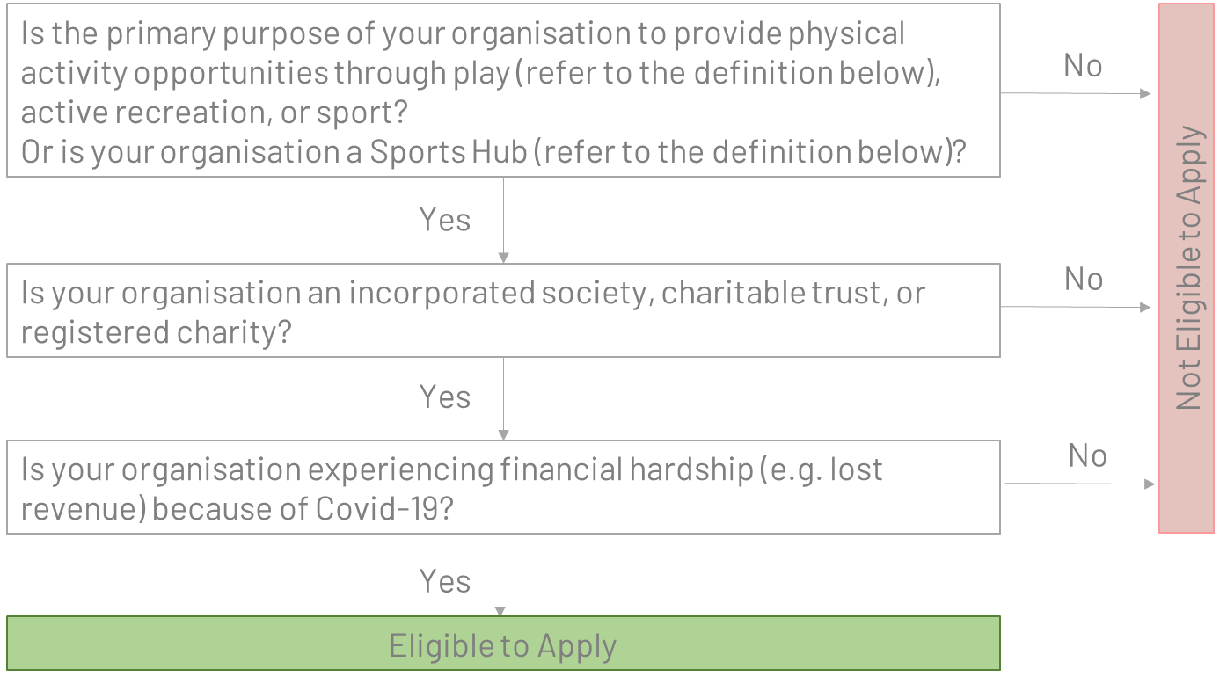
Play
To be eligible as a provider of physical activity opportunities through play, organisations must:
- have a primary purpose of supporting active play for tamariki aged 5-11 years, and
- be a financial member of either the International Play Association Aotearoa New Zealand or Recreation Aotearoa.
Play must be intrinsically motivated, freely chosen by tamariki, for no pre-determined outcomes, and with limited or no adult-led involvement. Our focus for play is an opportunity that happens outside curriculum - any delivery that is aligned to play-based learning (curriculum) is outside this scope.
Community Sport and Recreation Hubs
A Sports Hub is a partnership where organisations co-locate or share facilities and/or services strategically, sometimes via an independently governed group, within a defined geographical area, to provide sustainable, quality sport and recreation experiences.
To be an eligible Sports Hub, you must be:
- an established operating sports hub with two or more sports clubs that are affiliated to their relevant Regional Sport Organisation (RSO).
- able to demonstrate that there is wider community engagement, availability and use of hub facilities and services to the wider community.
- able to demonstrate that you are delivering initiatives on behalf of members and wider community interests to improve rates of community participation in play, active recreation and sport.

Application Form

These are the questions in the application form. We recommend that you review these carefully and make notes before you start the application process, to make sure you have all the information you need before you begin. Your application must be submitted in the form provided.
Eligibility
If your organisation’s main purpose (Q1) or organisation type (Q3) is not in the drop-down box, you are not eligible for the Community Resilience Fund Phase 2.
- What is your organisation's main purpose? (Play, Active Recreation, Sport, Sports Hub)
- Please describe how your organisation gets people physically active through play, active recreation or sport
- What type of organisation are you? If you are more than one, just select one. (Incorporated Society, Charitable Trust, Registered Charity)
- What is your Incorporated Society Number or New Zealand Business Number (NZBN)? We will look these up on https://www.nzbn.govt.nz/
About your organisation
- Applicant Details
Name of person applying
Organisation name
Address
Address 2
City/Town
Province
Postal code
Role in the organisation
Email Address
Phone Number
- I authorize my contact details to be added to Sport NZ’s and the RST’s contact lists. (Your answer will have no impact on the assessment of your application.)
- If you're affiliated to a Sport NZ partner please select the organisation from the list. If you are not affiliated to a Sport NZ partner, or you're a Sports Hub, please select Other.
- How many annual members or participants does your organisation have?
- Are your members or participants individual people or organisations?
Organisation’s GST and Bank Account Details
- Is your organisation registered for GST?
- What is your organisations GST number?
- What is your organisation's bank account name?
- What is your organisation's bank account number?
- Please attach a photo or screenshot of your latest bank statement, with the bank account name and number clearly shown.
- Are you applying for more than $5,000?

Application for Funds – More than $5,000 and up to $25,000 Maximum
- What was your total income for your last financial year ($)?
- What were your total expenses for your last financial year ($)?
- What were your salaries or wage costs for your last financial year?
- How much income will your organisation lose this year as a result of Covid-19? (We know this will be an estimate. Please simply provide your best estimate, thinking about revenue lost in the 12 months from 1 April 2020.)
- Please describe the lost income and how you've calculated it.
- What changes have you made to manage the impact of Covid-19? Describe decisions, actions, when they were taken, and the result. For example, outcome if you applied for the Government wage subsidy, what costs you have already reduced, how you have already used or are planning to use available cash reserves.
- Costs you are applying for – list each cost and amount. E.g. “Actual Electricity bills July to August $xx”, “Pro-rated insurance bill for three months”. Note that we will cover fixed administration and operating costs for the period 1 July to 30 September 2020, affiliation fees that are payable in the period 1 April to 30 September 2020, and up to three months’ worth (pro-rated) of audit and insurance costs, only. These amounts may be from actual bills received already, or estimated costs (except affiliation fees). If your costs are pro-rated, please tick the Pro-rated? box.
- Do these costs include GST?
- If your organisation has any reserves or savings, please tell us the $ value
- Please detail any supporting information for Q24 e.g. amounts that are already contracted, or have been set aside for specific projects, and what they are committed/intended for
- Please attach a copy of your latest audited financial statements. These must be no more than 18 months old. i.e. the end date of the financial statements must not be earlier than January 2019.

Application for Funds – Up to $5,000 Maximum
- How much income will your organisation lose this year as a result of Covid-19? (We know this will be an estimate. Please simply provide your best estimate, thinking about revenue lost in the 12 months from 1 April 2020.)
- Please describe your financial hardship as a result of Covid-19.
- What changes have you made to manage the impact of Covid-19? Describe decisions, actions, when they were taken, and the result. For example, outcome if you applied for the Government wage subsidy, what costs you have already reduced, how you have already used or are planning to use available cash reserves.
- Costs you are applying for – list each cost and amount. E.g. “Actual Electricity bills July to August $xx”, “Pro-rated insurance bill for three months”. Note that we will cover fixed administration and operating costs for the period 1 July to 30 September 2020, affiliation fees that are payable in the period 1 April to 30 September 2020, and up to three months’ worth (pro-rated) of audit and insurance costs, only. These amounts may be from actual bills received already, or estimated costs (except affiliation fees). If your costs are pro-rated, please tick the Pro-rated? box.
- Do these costs include GST?
- Please tell us the value of your organisation’s reserves or savings, that have not been committed or intended for other use.
- Please attach a copy of your latest financial statements. These must be no more than 18 months old. i.e. the end date of the financial statements must not be earlier than January 2019.

Conditions of application
- I confirm that I am authorised to submit this application on behalf of the organisation, and that our directors and/or trustees and/or treasurer are aware of and support this submission.
- I confirm that information in this application is correct, and that any amount we receive as a result of this application will be used as specified in our application form.
- I acknowledge that Sport NZ has the right to audit the information provided in this application and the use of any funds granted. I will provide full cooperation in the event of such an audit being undertaken.
- I note the “Protecting your information” section of the “Sport NZ Community Resilience Fund Phase 2 Guidelines”. We authorise Sport NZ to make such enquiries as it deems fit in considering the application (including banking details) and we accept and agree that details of any grant Sport NZ makes to our organisation may be made public.

Protecting your information
Before completing an application, please read the following information regarding Sport NZ’s obligations in relation to the information you will provide with your application. You should only proceed if you are happy to comply with these requirements.

Official Information Act 1982
The Official Information Act 1982 (OIA) covers how Sport NZ must handle requests for its official information. Applications for funding are among the documents that can be requested under the OIA. The general expectation, as expressed by the Chief Ombudsman, is for official information to be released (either pro-actively or in response to a request), unless there are clear grounds to withhold it. Personal information provided with your application will not be released.

Privacy Act 1993
The Privacy Act 1993 covers how Sport NZ and Regional Sports Trusts collect and store personal information, including personal information provided with applications for funding, and what procedures are required to protect the security of that information. It also covers how long we can keep personal information, what the personal information can be used for and when it can be disclosed.
We might use personal information provided by you in order to conduct appropriate identity checks.
Personal information can be corrected or updated by the applicant at any time once the information is submitted.
For further information on the Privacy Act, please refer to the following website:
https://privacy.org.nz/your-rights/your-privacy-rights/the-privacy-principles/

Accuracy of your information
It is the responsibility of the applicant to ensure that all information contained in the application is accurate. If you provide false or inaccurate information in your application or at any point in the process, and fraud is identified, we will provide details to fraud prevention agencies. You must undertake to inform all Directors, Trustees and Committee members of this notice.

